**Day 3 Assignment - Vamsi Viswanadham**

Worked on the below concepts.

* Implementing Data Integrity
* Using Functions to Customize the Result Set
* Using String Functions
* Using Date Functions
* Using Mathematical Functions
* Using System Functions
* Summarizing and Grouping Data
* Summarizing Data by Using Aggregate Functions
* Grouping Data
* Hands on Exercise: Filtering Data using SQL Queries
* Hands on Exercise: Total Aggregations using SQL Queries
* Hands on Exercise: Group By Aggregations using SQL Queries
* Hands on Exercise: Order of Execution of SQL Queries
* Hands on Exercise: Rules and Restrictions to Group and Filter Data in SQL queries
* Hands on Exercise: Filter Data based on Aggregated Results using Group By and Having

Here is a screenshot of the work.

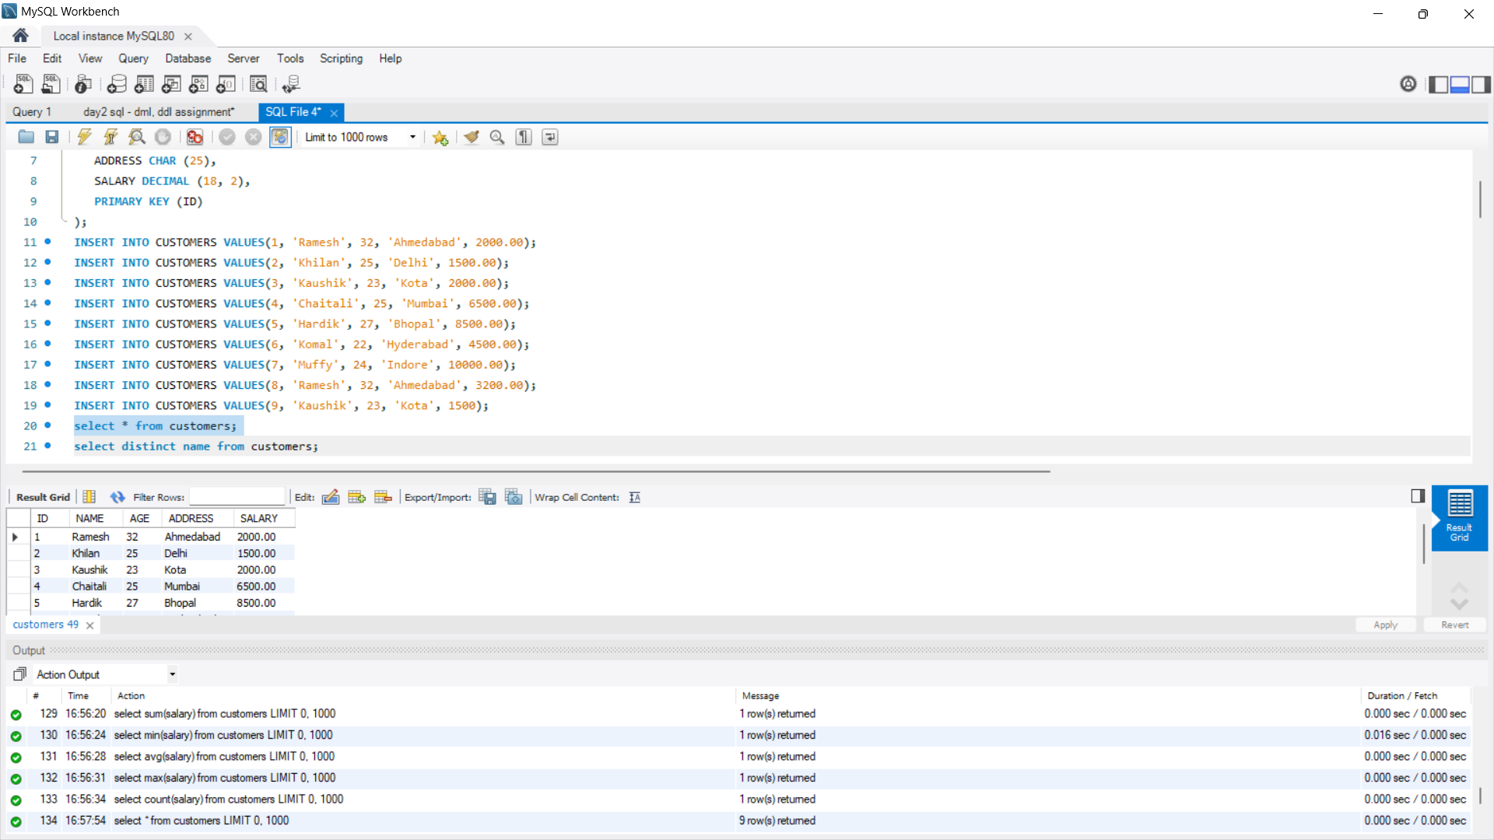

Here is a [sql file](https://drive.google.com/file/d/1DkWqERyZL1D9mBVu1a3kwavWNdnuiDB-/view?usp=sharing) of the work.